Name:__________________________ Period:_______ Tuesday, October 31, 2017

Decimal Operations Review

1 Farmer Green grows 0.9 tons of grain each year. Seven tenths of the grain grown is barley. Which model shows the amount of barley grown each year?

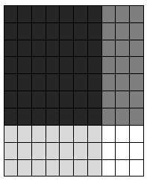
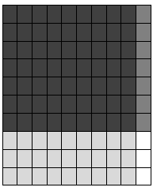

A B

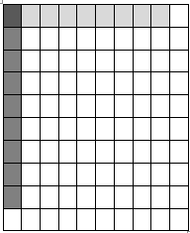
C D

2 Mr. Symank bought 32 packs of colored paper for the 5th grade. The total amount he had to pay was $167.04 for the paper. How much did one pack of paper cost if each pack of colored paper cost the same amount?

4 Ryan bought 23.6 pounds of candy for the fall festival. Each pound cost $0.75. How much did Ryan spend in total on the candy?

5 Christian has a video game with five different challenges. He sets the timer to play his game for 10.75 minutes. He spends the same amount of time playing each challenge. How many minutes will Christian play each challenge?

6 Which multiplication equation represents the model below?
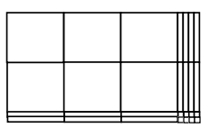

A 3.2 x 3.4 = 7.48 B 2.2 x 3.4 = 7.48

C 3.2 x 2.4 = 7.68 D 3.48 x 2.2 = 7.656

7 A baker sells a dozen cupcakes for $24.36. If each cupcake is the same price, what is the cost of one cupcake?

A $20.30

B $2.30

C $20.03

D $2.03

8 Compare the following using >, <, or =.

8.19 81.9

0.6690 0.669

9 Johnny went to the pumpkin patch to pick up some pumpkins.
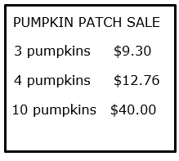

How many pumpkins should Johnny buy to get the best deal?

9 Coach Velez bought ribbon to make medals for the soccer team. The ribbon coast $0.09 per foot. How much did Coach Velez spend if he purchased 16 feet of ribbon?

A $1.44

B $14.40

C $144.00

D $1.40

10 Abby went for a swim in the local swimming pool. She swam a total of 1.5 kilometers in 5 minutes. If she swam the same speed the entire time, how many kilometers did she swam each minute?
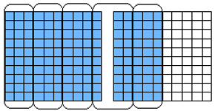

11 Cameron had a stack of twelve books that is 36.6 centimeters tall. If each book is the same height, how tall is each of the books?

A 30.5 centimeters

B 3.5 centimeters

C 3.05 centimeters

D .305 centimeter

14 Which equation represents the model below?
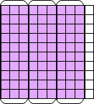

A 0.9 x 3 = 0.3 B 0.3 x 0.9 = 3

C 0.3 ÷ 3 = 0.9 D 0.9 ÷ 3 = 0.3

15 Rebekah ate 1.26 jars of yogurt parfait this morning. Each jar contained 0.31 ounces of granola. What was the number of ounces of granola Rebekah ate this morning?

16 Sarah worked 7.5 hours per day on 5 days last week. She earned $10 per hour. How much money did Sarah earn last week?

